Year 12 Physics
Unit 4
Wave Particle Duality and the Quantum Theory
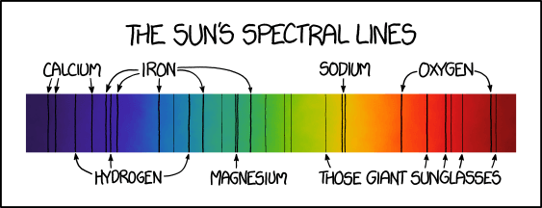

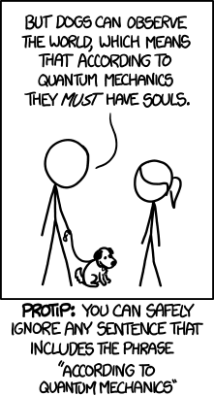
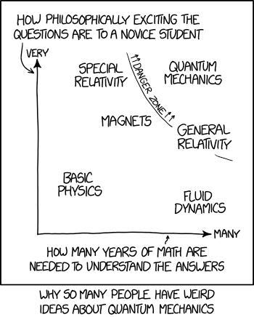

(Munroe, n.d.)

Name:
Proposed timeline

Wk | # | Topic | Practical activities | STAWA Questions | Pearson Physics
9 | 1 | Reflection and refraction | Reflection, refraction, diffraction with light boxes  Polarising lenses |  | pgs 232-247
9 | 2 | Polarization and interference |  |  | pgs 232-247
9 | 3 | Diffraction |  |  | pgs 232-247
9 | 4 | Double-slit experiment |  |  | pgs 232-247
9 | 5 | Path difference and fringe separation |  |  | pgs 232-247
10 | 1 | Travel through a vacuum | Youngs double-slit experiment  Diffraction with laser STAWA 12.3 | Set 12.1 | pgs 248-259
10 | 2 | Electromagnetic waves |  | Set 12.1 | pgs 248-259
10 | 3 | Blackbody radiation |  | Set 12.1 | pgs 248-259
10 | 4 | Planck-Einstein relation |  | Set 12.1 | pgs 248-259
10 | 5 | PL day
1 | 1 | PL day
1 | 2 | Photoelectric effect |  |  | pgs 260-270
1 | 3 | Photoelectric effect |  |  | pgs 260-270
1 | 4 | Task 8: Behaviour of light validation |  |  | pgs 260-270
1 | 5 | Compton scattering and de Broglie wavelength |  |  | pgs 260-270
2 | 1 | Atomic absorption and emission | Discharge tubes and spectroscopes STAWA 12.4 & 12.5 |  | pgs 271-278, 285-301
2 | 2 | Energy level diagrams | Discharge tubes and spectroscopes STAWA 12.4 & 12.5 |  | pgs 271-278, 285-301
2 | 3 | Band spectra | Discharge tubes and spectroscopes STAWA 12.4 & 12.5 |  | pgs 271-278, 285-301
2 | 4 | Fluorescence and phosphorescence | Discharge tubes and spectroscopes STAWA 12.4 & 12.5 |  | pgs 271-278, 285-301
2 | 5 | Lasers | Discharge tubes and spectroscopes STAWA 12.4 & 12.5 |  | pgs 271-278, 285-301
3 | 1 | Stellar spectra | Fluorescence and Phosphorescence STAWA 12.10  Measuring Planck’s constant with LED STAWA 13.4 | Set 12.2,  Set 13 | pgs 278-282
3 | 2 | Photovoltaic cells |  | Set 12.2,  Set 13 | pgs 278-282
3 | 3 | LEDs |  | Set 12.2,  Set 13 | pgs 278-282
3 | 4 | X-ray generation |  | Set 12.2,  Set 13 | pgs 278-282
3 | 5 | Revision |  | Set 12.2,  Set 13 | pgs 278-282
4 | 1 | Standard Model – Big Bang Theory
4 | 2 | Standard Model – Big Bang Theory
4 | 3 | Standard Model – Big Bang Theory
4 | 4 | Task 9: Light and quanta topic test
4 | 5 | Standard Model – Big Bang Theory

SCSA ATAR Syllabus
https://senior-secondary.scsa.wa.edu.au/syllabus-and-support-materials/science/physics

Science Understanding

- light exhibits many wave properties; however, it cannot only be modelled as a mechanical wave because it can travel through a vacuum
- a wave model explains a wide range of light-related phenomena, including reflection, refraction, dispersion, diffraction and interference; a transverse wave model is required to explain polarization
- electromagnetic waves are transverse waves made up of mutually perpendicular, oscillating electric and magnetic fields
- oscillating charges produce electromagnetic waves of the same frequency as the oscillation; electromagnetic waves cause charges to oscillate at the frequency of the wave
- atomic phenomena and the interaction of light with matter indicate that states of matter and energy are quantized into discrete values
- on the atomic level, electromagnetic radiation is emitted or absorbed in discrete packets called photons. The energy of a photon is proportional to its frequency. The constant of proportionality, Planck’s constant, can be determined experimentally using the photoelectric effect and the threshold voltage of coloured LEDs

This includes applying the relationships
$$c=fλ, E=hf=\frac{hc}{λ}, E_{k}=hf-W, de Broglie λ=\frac{h}{p}$$
- a wide range of phenomena, including black body radiation and the photoelectric effect, are explained using the concept of light quanta
- atoms of an element emit and absorb specific wavelengths of light that are unique to that element; this is the basis of spectral analysis

This includes applying the relationships
$$ΔE=hf, E_{2}-E_{1}=hf$$
- the Bohr model of the hydrogen atom integrates light quanta and atomic energy states to explain the specific wavelengths in the hydrogen spectrum and in the spectra of other simple atoms; the Bohr model enables line spectra to be correlated with atomic energy-level diagrams
- on the atomic level, energy and matter exhibit the characteristics of both waves and particles. Young’s double slit experiment is explained with a wave model but produces the same interference and diffraction patterns when one photon at a time or one electron at a time are passed through the slits

Science as a Human Endeavour

Models that were initially rejected can be revisited as more evidence becomes available. For many years, the presence of luminiferous ether was proposed as the medium by which light is propagated. Around 1800, Thomas Young showed through experimentation that light passing through a double slit showed interference and thus wave properties. The wave explanation of Young’s double slit demonstration was initially rejected until other physicists, including Fresnel and Poisson, showed that light was able to undergo diffraction, a property of waves. Later, in the 1860s, James Clerk Maxwell developed a theory of electromagnetism and showed that electromagnetic waves would travel through space at the speed of light, implying light was an electromagnetic wave.
The use of devices developed from the application of quantum physics, including the laser and photovoltaic cells, have significantly changed many aspects of society.

Is light a wave or a particle?
Wave behaviour | Explained by wave? | Explained by particle?
Reflection | Yes | Yes
Refraction | Yes | Yes
Polarization | Yes | (Yes)
Interference | Yes | No
Diffraction | Yes | No
Photoelectric effect | No | Yes
Compton scattering | No | Yes

- Some of light’s behaviour can be explained with either a wave or particle model for light. However, some requires that it is a particle, and some requires that it is a wave.
- The question remains; is light a wave or a particle?
- Is it both at all times?
- Is it sometimes one, and sometimes the other?

Reflection
- When light strikes a surface, it bounces off in a consistent way
Angle of reflection
Angle of incidence
Normal
Incident ray
Reflected ray

- Wave or particle? – Inconclusive, both waves and particles reflect in this manner

Refraction
- A change in speed of light as it enters a new medium at an angle causes light to bend
- The change in speed is accompanied by a change in wavelength as frequency remains constant
- If light speeds up, it will bend away from the normal
- If light slows down, it will bend towards the normal
- Remember FAST - Fast Away Slow Towards

normal
surface
slow
fast

- Wave or particle? – Inconclusive, while typically thought of as wave behaviour, it can be explained by the particle model e.g. marching band cornering, car changing surfaces at an angle

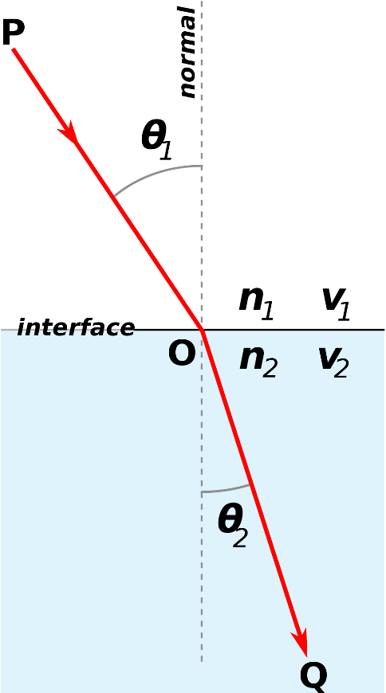
Snell’s Law
- Formula for calculating angle of refraction – not in syllabus but can come up if the equation is given to you

$$\frac{\sin{θ_{2}}}{\sin{θ_{1}}}=\frac{v_{2}}{v_{1}}=\frac{n_{1}}{n_{2}}$$

$$θ=angle from the normal (°)$$
$$v=speed (m s^{-1})$$
$$n=refractive index (relative measure of speed of light)$$

Complete the diagrams below showing the refracted ray and wavefronts
air
glass
water
air
Dispersion
- As white light (mixture of all colours) is refracted, the different colours refract different amounts – spreads out the colours
- Shorter wavelength (more blue) light bends more
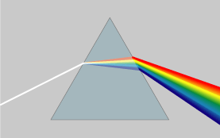

Total internal reflection
- Light striking a surface with a faster medium at a steep angel can be completely reflected with no transmission
- Fibre optics, diamonds, underwater surface reflections etc.

$$θ_{c}=\sin^{-1}{\frac{n_{2}}{n_{1}}}$$
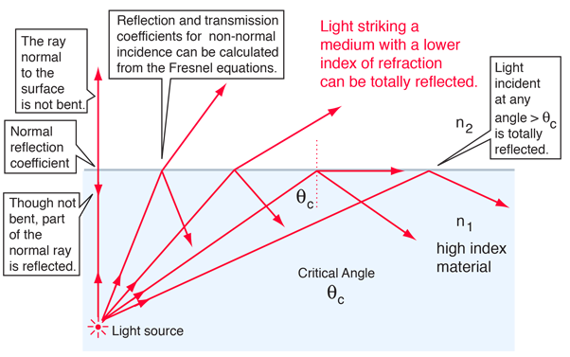

Example
- A pulse of light enters a fibre optic cable (n=1.33) at 50° from air (n=1.00). Find the angle of refraction and the critical angle inside the fibre optic cable.

Polarization
- Oscillation of light’s electric and magnetic fields are always perpendicular to the direction of propagation (transverse wave) but they can be at any rotation
- Light can be filtered to only allow light of a specific orientation through
- Wave or particle? – Most simply and intuitively explained by light as a wave (specifically a transverse wave) but quantum mechanics relates polarization to photon spin allowing for a particle interpretation
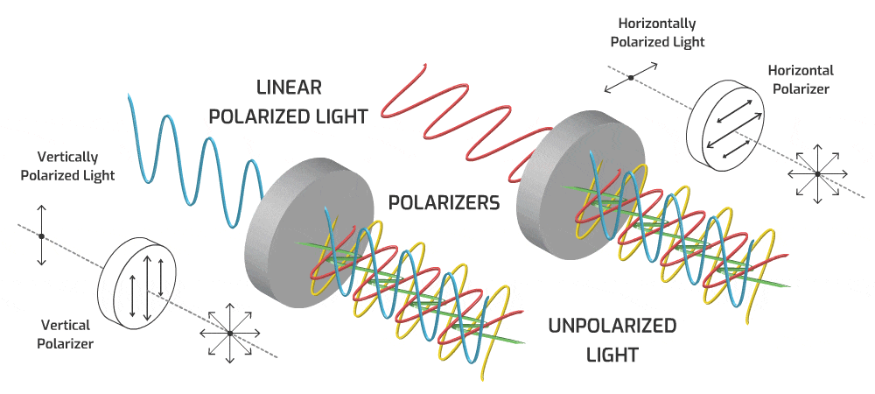
- Polarization occurs naturally when light reflects off non-metallic surfaces – the light is partially polarized in the horizontal direction
- Vertically polarized sunglasses can then selectively filter out reflected glare off water and snow etc.
- Two polarizing filters at right angles should block all light
- Some materials rotate the polarization of light or interact with polarization in other ways – allows for optical analysis of rocks, stressed materials etc.

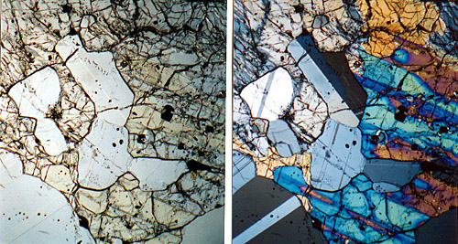
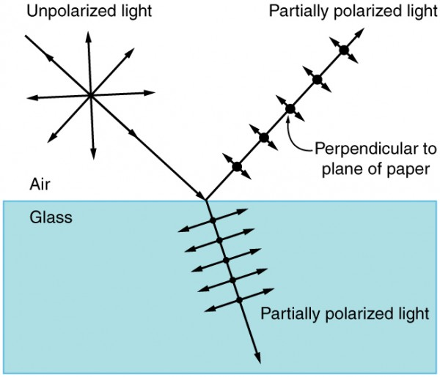

Interference – superposition
- When two waves overlap, they interfere
- Can be thought of as a vector sum of the two waves
- The waves pass through each other unchanged
- If the waves are out of phase (i.e. peak meeting trough) then destructive interference occurs (decreased amplitude)
- If the waves are in phase (i.e. peak meeting peak) then constructive interference occurs (increased amplitude)
- Wave or particle? – Interference is fundamentally a wave behaviour

Interference in two dimensions

- Complex patterns emerge with interference in 2D
- Wavefronts show crests, troughs centered between wavefro nts
- Zones of constructive interference (antinodal lines) in red, zone of destructive interference (nodal lines) in-between

Diffraction
- Bending of light around the corners of an obstacle or as it passes through a gap – result of interference (two words sometimes used interchangeably – can get messy)
- The smaller the gap, the more the waves bends
- The larger the wavelength, the more the waves bend
- Only significant when wavelength is approaching the same size as the gap (or is bigger)
- With strong diffraction the gap functions as a new point source for the wave
- Wave or particle? – Diffraction is fundamentally a wave behaviour – alarming that electrons and even neutrons have also been shown to diffract…
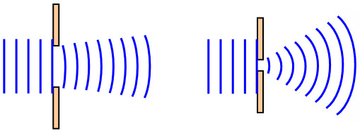
Example
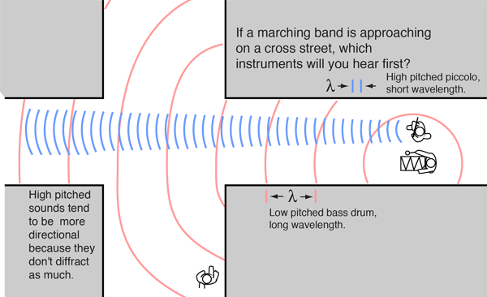

- If light is a wave that diffracts, why can we not see around corners?

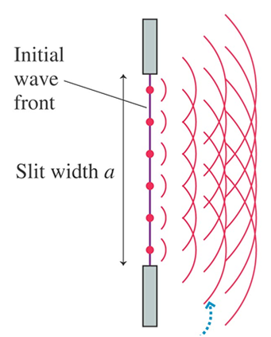
Explaining Diffraction
- Huygen’s principle – every point on a wavefront can
be through of as a point source
- All of these point sources interfere to create the
wavefronts that we observe
- When part of a wavefront is obstructed, the end of the
wavefront next to the obstacle can be seen acting like
a point source because there is no interference from
the rest of the wavefront that is obstructed
- Results in the wave appearing to bend around
corners

ATAR example
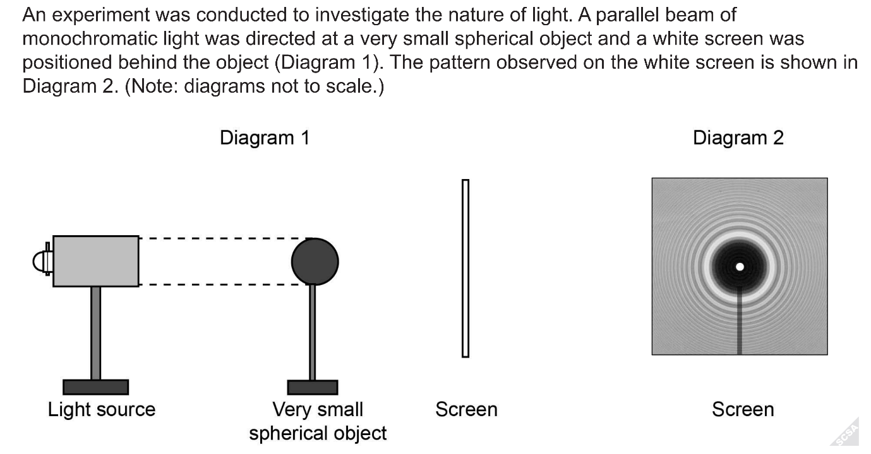
- Discuss how the pattern in Diagram 2 was formed.

- From this experiment what conclusion can be made regarding light?
Double-slit experiment
- Light shone at barrier with two small slits – resulting pattern of light on the other side of the barrier observed
- If light is a particle then it should only be visible on the other side of the barrier directly in line with the slits
- If light is a wave then an interference pattern should be visible cause by diffraction
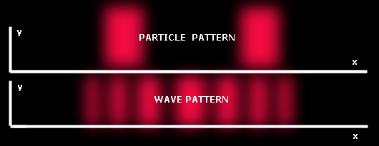

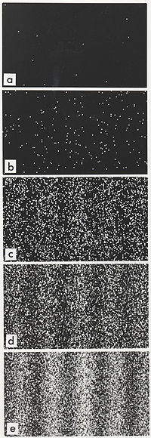
- With the right slit diameter, the light diffracts from each slit – each slit behaves like a point source
- Light from the two slits interferes creating alternating bands of constructive and destructive interference – alternating bands of high and low intensity referred to as fringes
- Bright fringes numbers from 0th in the center increasing out in both directions
- Wave or particle? – Diffraction is fundamentally a wave behaviour

Double-slit experiment with single photons, electrons, atoms or even molecules
- If the experiment is repeated only firing a single particle at a time, the behaviour of the particles appears strange
- They do not follow the expected particle pattern, instead as more particles pass through it becomes clear that the wave pattern is forming
- Particles even as large as buckyballs (C₆₀) must have a wave nature and even a wavelength

Double-slit experiment – Path difference
- Effectively have two in-phase point sources interfering with each other – at points where waves arrive in phase constructive interference occurs, at points where the waves arrive exactly out of phase (referred to as 180° out of phase) destructive interference occurs
- The phase relationship at a point in space is determine by the path difference between the two waves – the difference between the distances the two waves must travel to reach that point
- If the path difference is an integer multiple of the wavelength then the waves arrive perfectly in phase - constructive interference occurs
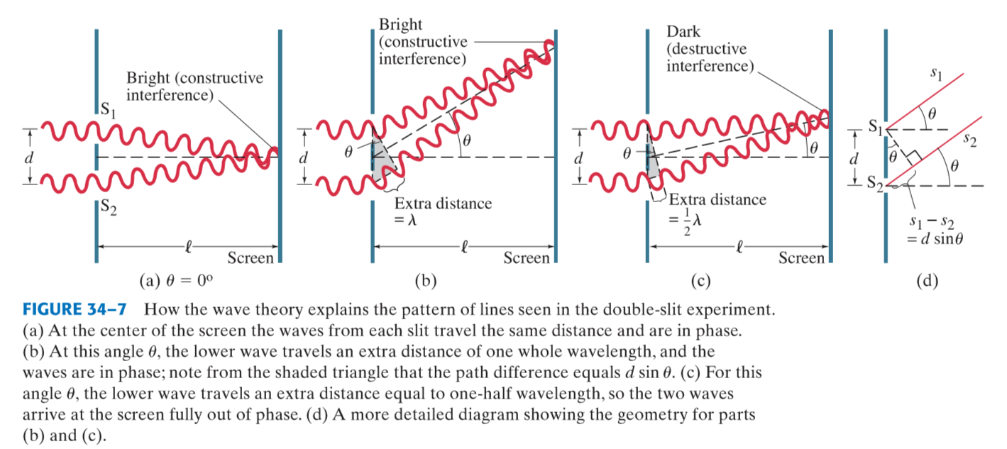
- If the phase difference is a half-integer multiple of the wavelength then the waves arrive 180° out of phase – destructive interference occurs

Variations on the double-slit experiment and calculations
d
nλ
θ
θ
D
x

Single slit/obstacle | Double/multiple slit | Diffraction grating
Integer path differences are minima (dark fringes) | Integer path differences are maxima (bright fringes) | Integer path differences are maxima (bright fringes)
Fringe separation appears constant | Fringe separation appears constant | Fringe separation increases moving out from 0th maximum
0th maximum is double width  $$x$$  0th |  | Slits typically narrower and closer together, small –angle approximation less appropriate
$$a=\frac{nλD}{x}$$ | $$d=\frac{nλD}{x}$$ | $$d=\frac{nλ}{\sin{θ}}$$  $$θ=\tan^{-1}{(\frac{x}{D})}$$
$$a=width of slit/obstacle$$  $$nλ=path difference$$  $$\left(integer multiple of wavelength\right)$$  $$D=distance from slit/obstacle$$  $$to screen$$  $$x=distance from midpoint$$  $$to n^{th} minimum$$ | $$d=distance between slits$$  $$nλ=path difference$$  $$\left(integer multiple of wavelength\right)$$  $$D=distance from slits to screen$$  $$x$$  0th  $$x$$  0th  $$x=distance from midpoint$$  $$to n^{th} maximum$$ | $$d=distance between slits$$  $$nλ=path difference$$  $$\left(integer multiple of wavelength\right)$$  $$θ=angle between midline$$  $$and line to nth maximum$$  $$D=distance from grating$$  $$to screen$$  $$x=distance from midpoint$$  $$to n^{th} maximum$$

- Not in the syllabus but could be given to you
Example
- A 3.75 x10¹⁴ Hz laser was shone at a fine wire producing an interference pattern on a screen 3 m away. If the distance between the two 5th maxima was 12 cm determine the thickness of the wire.
x

D
Travel through a vacuum
- Light is able to travel through a vacuum with no medium to carry it
- Wave or particle? – Can be a particle, cannot be a mechanical wave – special type of wave required – electromagnetic wave

Light as electromagnetic waves
- So far light can be explained as a self-propagating electromagnetic wave
- A pair or perpendicular oscillating electric and magnetic fields
- Direction of oscillation is perpendicular to the direction of propagation – transverse wave
- Transmits energy (without transmitting matter)

Wave equation
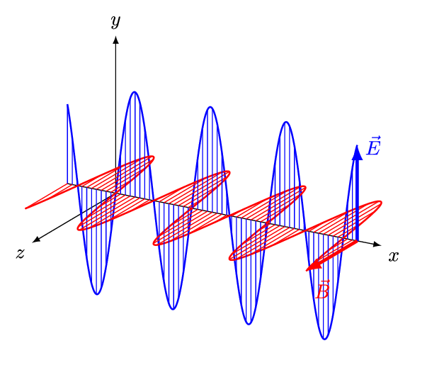
$$c=fλ$$

$$c=speed of light=3×{10}^{8} \left(m s^{-1}\right)$$
$$f=frequency \left(Hz=s^{-1}\right)$$
$$λ=wavelength \left(m\right)$$
$$\frac{1}{f}=T=period (s)$$

Wave characteristics
- Frequency: number of waves passing a point each second
- Period: The time it takes for a wave to repeat itself
- Wavelength: length of 1 complete wave
- Amplitude: the largest magnitude of the oscillation in the electric or magnetic fields

Electromagnetic spectrum
- Light’s properties vary over a spectrum
- Radio waves, microwaves, infrared radiation, visible light, ultraviolet radiation, X-rays and gamma rays are all light - are all electromagnetic waves
- They have varying properties due to varying frequency/wavelength
- Bear in mind that since the speed of light is constant, a wave of a specific frequency must have a specific wavelength and vice versa

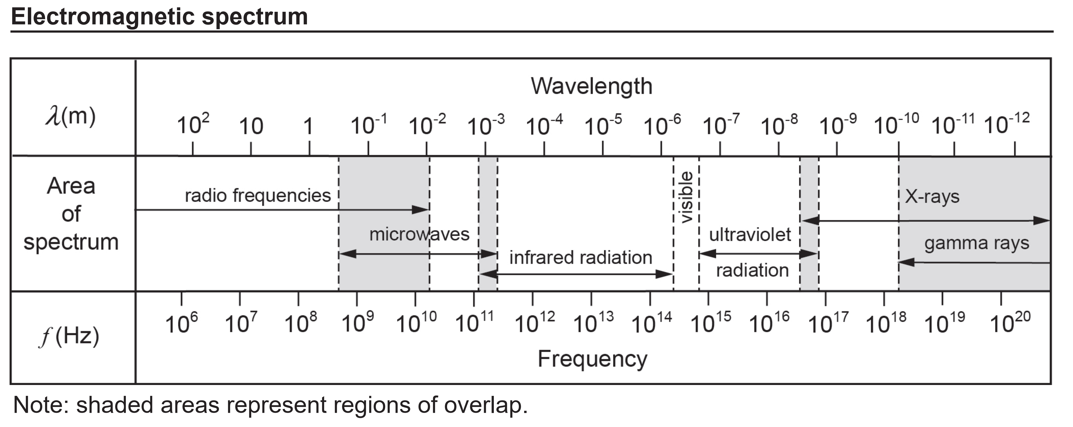
Use the spectrum above to estimate the frequency and wavelength of red light

- This spectrum from the datasheet is not perfectly to scale (should be logarithmic scale) - most important thing is that the order of magnitude is correct (particularly tricky with wavelength – read right to left)

Examples
What is the wavelength of emr with a frequency of 3x10¹⁶ Hz?

What type of radiation is it?

What is the wavelength of TV signals transmitted at 527.25 MHz?

Type | Wavelength (m) | Source | Uses | Physiological effects
Gamma rays
X-rays
UV radiation
Visible light
IR radiation
Microwaves
Radio waves

Blackbody radiation
- All object with a temperature above 0 K emit energy as emr
- A blackbody is a theoretical ideal object that absorbs and emits all frequencies of emr ‘perfectly’
- Some real objects approach blackbody behaviour – vantablack, black holes
- It is useful to model the behaviour of stars and planets as blackbodies

Blackbody radiation spectrum
- Blackbody radiation is always a range of different frequencies
- The intensity of different frequencies varies only with temperature
- As the temperature of the blackbody increases, the dominant wavelength emitted decreases – the dominant frequency increases
- This is why heated objects (including stars) first glow red-hot, then white-hot and finally blue-hot
- The total energy emitted (area under the curve) increases dramatically with temperature
- Classical theories (shown in black) could not match the empirical evidence (red, green and blue) – intensity of light emitted approaches infinity as wavelength approaches 0 – UV catastrophe
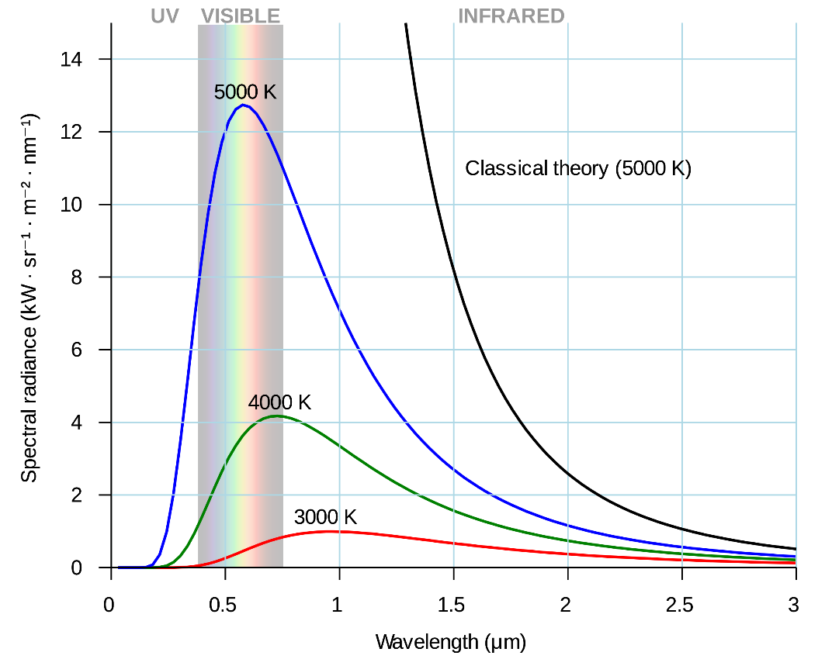

Planck to the (accidental) rescue
- Desperate to devise a mathematical model that matched the empirical observations Planck tried quantizing light
- By making it so only discrete values are allowed for quantity of energy, the mathematical models could now match the empirical observations
- Light could no longer be a true spectrum where any quantity of energy was possible
- Important to note that this quantization is so fine that at the large scale it is fine to treat it as a continuous spectrum
- Wave or particle? – Quantization isn’t compatible with our classical understanding of waves – so is light a particle?

Example
An experiment was conducted to observe changes in colour and intensity as a bar of dull grey tungsten metal was heated from room temperature.

When heated to 200 °C the tungsten is observed as remaining grey and dull. When heated to 700 °C the tungsten is observed as red and dull, and at 2700 °C the tungsten is observed as white and bright.

- Describe why the colour and intensity of the tungsten changes as it is heated.

The tungsten is heated further until it starts melting at approximately 3400 °C

- Sketch labelled graphs of intensity against wavelength for the two observed spectra at 2700 °C and 3400 °C.

Quantized vs continuous light

Continuous  - For a certain frequency – any energy is possible  - Energy changed by varying the amplitude of the wave | Quantized  - For a certain frequency – the energy must be an integer multiple of a certain quantity  - Energy changed by changing the number of particles of light (photons)

Planck-Einstein relation
$$E=nhf$$

$$E=energy of light \left(J\right)$$
$$n=integer=number of particles of light (photons)$$
$$h=planck constant=6.63×{10}^{-34} J s$$
$$f=frequency of light \left(Hz\right)$$

For a given frequency of light only certain energies are allowed which are integer multiples of a base quantity.
For example, for light with a frequency of 1 Hz, only integer multiples of 6.63x10⁻³⁴ J are allowed quantities of energy.

Planck-Einstein relation – energy of a single photon

$$E=hf=h\left(\frac{c}{λ}\right)$$

$$E=energy of a photon \left(J\right)$$
$$h=planck constant=6.63×{10}^{-34} J s$$
$$f=frequency of photon \left(Hz\right)$$
$$c=speed of light \left(m s^{-1}\right)$$
$$λ=wavelength (m)$$

Examples
Determine the energy of a photon with a frequency of 2 MHz.

If a photon has 6x10⁻¹⁸ J, what type of radiation is it?

What is the previous photon’s wavelength?

A 100 W lightbulb produces light of 450 nm. How many photons are released each minute?

Photoelectric effect
- When light strikes metal (can be any substance but easiest to observe in metals) under the right conditions, electrons are ejected from the surface of the metal – referred to as photoelectrons
- Interpretation is that electrons are given enough energy to break free from their electrostatic attraction to the nucleus
- If it isn’t working should just have to increase the energy delivered by the light
- Increasing the intensity of light classically thought to increase the amplitude of the wave which increases the energy carried by the wave – the light should then have enough energy to eject electrons, but it doesn’t work

- Found that rather than increasing amplitude, it was necessary to increase frequency
- Recall the Planck-Einstein Relation:
$$E=hf$$
- The energy of a single photon is directly proportional to its frequency
- Since increasing the amplitude (number of photons) didn’t work, but increasing the energy of each individual photon does, the effect must come down to collisions between individual photons and individual electrons
- When a photon with sufficient energy strikes an electron, the electron absorbs the energy of the photon gaining enough to break free of the atom
- Wave or particle? – Light must be a particle to explain why high frequency light is required to deliver enough energy to electrons while high intensity light cannot

Threshold frequency
- Threshold frequency (f₀) – minimum frequency needed to eject an electron – corresponds to the smallest binding energy of an electron (referred to as work function)
- Below f₀ literally no electrons are emitted
- At or above f₀ electron emission is instantaneous – there is no need for electrons to cumulatively gain energy
- At or above f₀ the rate of electron emission increases with increasing intensity
- At or above f₀ the maximum kinetic energy of emitted electrons increases with increasing frequency

- Different electrons required different amount of energy to be emitted (different binding energies)
Work function and kinetic energy of photoelectrons
- Work function (W or φ) is the minimum energy required to emit a photoelectron (minimum binding energy)
- Emitted photoelectrons have a range of kinetic energies up to a maximum
- The maximum kinetic energy is obtained when a photon strikes an electron with the minimum binding energy

$$E_{k(max)}=hf-W$$

- Exactly at the threshold frequency:

$$hf=W so E_{k(max)}=0$$

Measuring photoelectric effect
A
+
-
- Emitted photoelectrons can be attracted to a positively charged plate
- Two parallel plates with a voltage across them will accelerate photoelectrons from the negative plate towards the positive plate allowing a current to flow
- This current increases with voltage across the plates up to a limit – at this limit all emitted photoelectrons are being collected so there cannot be any further increase in current
- Increasing the intensity of the light will increase the maximum current as more photoelectrons are being emitted
- Note: still get some current at 0 voltage from the photoelectrons that happen to be emitted in the right direction

Stopping potential
A
+
-
- If the same circuit has the direction of the voltage reversed, photoelectrons will be repelled from the negative plate, reducing current
- Current will hit zero at a specific voltage – the stopping potential (V₀)
- V₀ corresponds to the E_{k(max)} – it is the voltage at which an electron with the maximum kinetic energy heading directly towards the negative plate will still be stopped by the electric field

$$E_{k(max)}=eV_{0}=\frac{1}{2}mv_{max}^{2}$$

$$e=electron charge=1.6×{10}^{-19}C$$
$$V_{0}=stopping voltage (V=J C^{-1})$$

I/V graphs – varying parameters
- Increasing frequency of the light increases the magnitude of V₀
- Increasing the intensity of the light increases the maximum current

Example
V
I
A sample of potassium is used as the cathode of a photocell with which the photoelectric effect is studied. When green light of a particular intensity is shone onto the cathode, the I-V graph above to the right is obtained. Also, the threshold frequency for this sample is found to lie in the yellow region of the visible spectrum.
- Sketch the I-V graph that would result if red light of the same intensity was incident upon the cathode.
- Sketch the I-V graph that would result if the intensity of the incident green light was doubled.
- Sketch the I-V graph that would result if violet light of a very low intensity was incident upon the cathode
- When UV light is incident upon the cathode the stopping voltage is found to be -2.25 V. Determine the maximum kinetic energy of the photoelectrons in joules and electronvolts.

Note on electron volts
- Unit of energy for small quantities
$$1eV=1.6×{10}^{-19}J$$
- Energy gained by an electron when accelerated through a potential difference of 1 V
- Stopping potential is the energy removed from an electron as it is accelerated through a potential difference
- Therefore V₀=E_{K(max)} in eV

Examples
Yellow-green light of 500 nm shines on metal with a stopping potential of -0.800V.
- What is the maximum velocity of photoelectrons produced?

- What is the work function of the metal in both joules and electronvolts?

Max E_{K} against frequency
$$E_{k(max)}=hf-W$$

- A graph of E_{k(max)} against frequency for a metal will produce a straight line with a gradient equal to the Planck constant, a y-axis intercept of its work function and an x-axis intercept of its threshold frequency
- Different metals have different work functions so their lines on such a graph will be offset from each other, but they will be parallel

Photon mass? Photon momentum?
- If a photon is a particle of light, does it have mass?

$$E=hf=mc^{2}$$
$$m=\frac{hf}{c^{2}}=\frac{h}{cλ}$$

- But this in incorrect due to special relativity – nothing that travels at the speed of light can have mass (relativistic equations needed to demonstrate)
- If a photon is a particle does it have a momentum?

$$ρ=mv=\frac{h}{cλ}c=\frac{h}{λ}$$

- As it happens, yes, and this derivation does give the correct formula
- Momentum is of interest due to fundamental law of conservation of momentum

Compton scattering
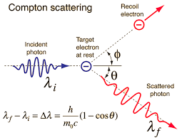
- In the photoelectric effect a photon’s energy is completely absorbed by an electron ejecting it from an atom
- If extremely high energy photons are used (e.g. X-rays) it is also possible for an electron to only absorb some of the photons energy – due to very large energy electron behaves as a free electron (E _{γ}>>W)
- Essentially a collision between a photon and a free electron – electron sent off at an angle, photon also continues at an angle with a longer wavelength
- Wave or particle? – If light were a wave, no change in the photon wavelength would be expected, instead we observe conservation of momentum as if two particles are colliding

Nature of light
- Light consists of photons – quanta of energy that behave as both a particle and a wave
- A single photon has energy and momentum

$$E=hf ρ=\frac{h}{λ}$$

- Generally light can be thought of as a wave at the macroscopic scale but must be treated as a particle at the individual photon scale

de Broglie wavelength
- If light is both a particle and a wave – maybe matter is too

$$ρ=\frac{h}{λ}=mv$$
$$λ=\frac{h}{mv}$$

- Demonstrated by the double-slit experiment conducted with electrons, protons and even molecules as large as buckyballs
- Generally, if a particle’s de Broglie wavelength is roughly the same size or larger than its physical size then quantum mechanics must be used to model its behaviour, otherwise classical physics will suffice

Electron energy levels as standing waves
- If an electron ‘orbits’ a nucleus as a standing wave it is stable – no loss of energy over time
- Electrons as standing waves can only have certain wavelengths and therefore certain energies to exist in orbitals - explains quantization of energy levels
- A wavelength is only allowed if an integer multiple of it matches the circumference of the ‘orbit’
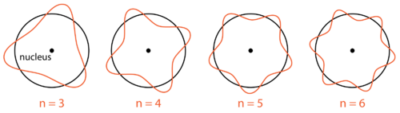

Examples
- Determine the wavelength of an electron travelling at 5.97x10⁶ m s⁻¹.

- What is the kinetic energy and wavelength of an electron travelling at 5.31x10⁶ m s⁻¹. Determine the voltage required to achieve these speeds.

Application of quantized light – atomic absorption and emission
- We have pinned down that light is quantized
- This can be used to explain both atomic emission and atomic absorption
- Atomic absorption: specific elements absorb specific colours of light
- Atomic emission: specific elements emit specific colours of light
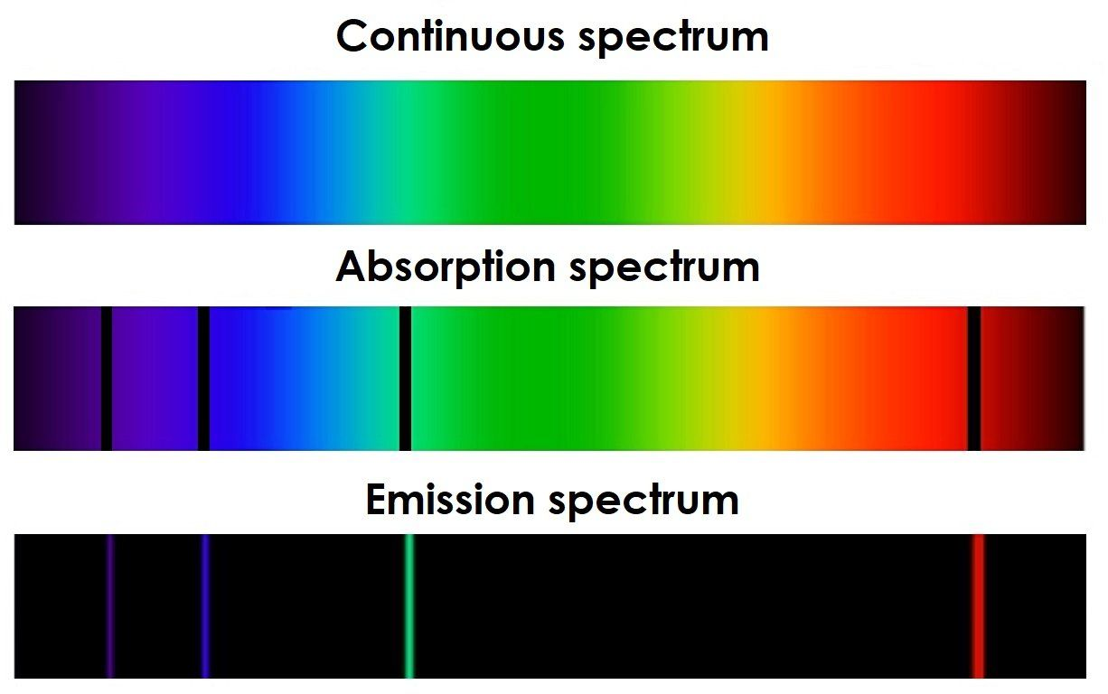
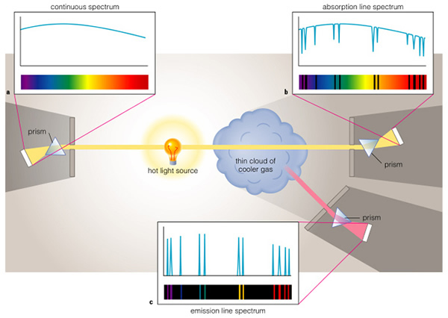
Atomic emission | Atomic absorption
Atoms of an element supplied with energy (e.g. electrical or thermal) emit light | Atoms of an element absorb light that is shone through them
Light typically emitted from heated gas | Light typically absorbed as it passes through cool gas
Only specific colours of light are emitted | Only specific colours of light are absorbed
The specific colours are unique to each element | The specific colours are unique to each element
The specific colours an element emits are mostly* the exact same colours that element will absorb | The specific colours an element absorbs are the exact same colours that element will emit
*There can be more emission lines than absorption lines due to transitions involving energy levels that don’t ordinarily contain electrons
Spectrum appears as lines of colour on a black background | Spectrum appears as lines of black on a rainbow background
The larger the element, the greater the number of specific colours that are emitted | The larger the element, the greater the number of specific colours that are absorbed

Understanding absorption and emission – atomic structure
- Something must be occurring in the atoms – need to understand atomic structure
- Simplest model suitable for explaining this phenomenon is the Bohr model
- Nucleus of positive protons and neutral neutrons containing almost all the mass “orbited” by negatively charged electrons
- Electrons orbit at specific energy levels commonly referred to as shells – electrons may not orbit between specific energy levels – their energy is quantised – only specific values are allowed
- Electrons orbit at the lowest available energy level and do not lose energy over time

Explaining emission
- When an atom gains energy (e.g. from an electrical current or heat) it is possible for individual electrons to gain energy
- However, electrons can only exist at specific energy levels – to gain energy an electron must jump to a higher energy level – referred to as an excited state
- This is unstable so the electron loses its extra energy to return to the ground state – the energy can’t simply disappear – it is emitted as a photon of light
- The initial energy level and the excited energy level both have specific energies so the change in energy is a specific quanta – leading to a specific colour of light

Explaining absorption
- When light shines through atoms (typically as a gas) individual photons collide with individual electrons
- If the energy of the photon is exactly the right amount to jump the electron up to a higher energy level then the photon will be completely absorbed – ceasing to exist – and the electron will become excited
- Only specific energies/colours of photon are absorbed – all other pass straight through

Incorrect energy for absorption
- If the incident photon has at least enough energy to ionize the electron then the electron will be ejected from the atom, absorbing the photon and gaining any excess energy as kinetic energy
- If the incident photon doesn’t have enough for ionization nor the exact right amount of energy to cause a transition then nothing will happen – this is why only specific colours are absorbed
- If the energy is supplied by another electron instead of a photon (e.g. due to an electric current) then the electron giving energy does not need to have the exact right amount of energy
- The absorbing electron will take as much energy as it needs for a transition leaving the other with the remainder – an electric current very easily excites electrons of any atom

Energy level diagrams
- Overly space consuming to draw energy level as circular orbits – energy level diagram

Ground state n=1
2nd excited state n=3
1st excited state n=2
3rd excited state n=4
4th excited state n=5
ionisation

- electron transitions shown as arrows
- energy of energy levels shown as negative values as they are the binding energy for an electron at that level – the energy the electron would have to gain to be removed from the atom
- energy levels numbered in order from the lowest energy level – known as the quantum number
- n=∞ used to refer to ionisation – the point at which an electron is removed from an atom
ionisation
ground state
1st excited state
2nd excited state
n = 1 E₁ = -13.6eV
n = 3 E₃ = -1.51 eV
n = 2 E₂ = -3.4 eV
n = 4 E₄ = -0.85 eV
n = 5 E₅ = -0.54 eV
n = ∞ E = 0 eV

Working with energy level diagrams

- Energy of photons absorbed or emitted can be determined by the energy difference between two energy levels
$$E_{photon}=hf=∆E=E_{n}-E_{m}$$

- e.g. an electron relaxing from n=2 to n=1 would emit a photon with 10.2 eV of energy (-3.4 - -13.6)
ionisation
ground state
1st excited state
2nd excited state
n = 1 E₁ = -13.6eV
n = 3 E₃ = -1.51 eV
n = 2 E₂ = -3.4 eV
n = 4 E₄ = -0.85 eV
n = 5 E₅ = -0.54 eV
n = ∞ E = 0 eV

Example
A ground state electron in a hydrogen atom is excited to n=3
a. how many unique energies of photon could be emitted as it relaxes
b. determine which (if any) of the emitted photons would be visible

Lyman, Balmer and Paschen series
- groups of transitions in hydrogen ending at the same energy level
- Balmer series identified early on because they fall within the visible spectrum
- Lyman series creates ultraviolet photons, while the Paschen series creates infrared photons
ionisation
ground state
1st excited state
2nd excited state
n = 1 E₁ = -13.6eV
n = 3 E₃ = -1.51 eV
n = 2 E₂ = -3.4 eV
n = 4 E₄ = -0.85 eV
n = 5 E₅ = -0.54 eV
n = ∞ E = 0 eV
.
Lyman
Balmer
Paschen

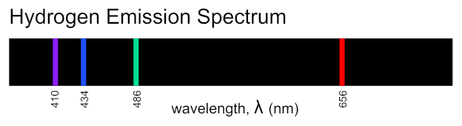

Band spectra
- In small atoms the change in energy of transitions is very well defined so the absorption/emission lines are sharp
- In larger atoms, and molecules, various factors* can cause small variations in the energy of energy levels – leading to variations in the change in energy of transitions
- This creates many different transitions of very similar energies – they blur together appearing as a wider band rather than a line



H



Fe

*temperature, pressure, inhomogeneity (e.g. surface effects), molecular vibration/rotation and even the doppler effect
Atomic emission - Gas-discharge lamps
- Current flows through plasma exciting electrons in the plasma
- Colour of light dependent on the element(s) in the plasma

Atomic emission – Fluorescence
- Certain materials glow with unexpected colours when exposed to invisible ultraviolet light – examples of fluorescence
- The invisible UV light is absorbed by electrons exciting them
- The electrons relax through multiple smaller transitions causing lower energy visible light to be emitted
- glow only visible while directly exposed to high energy light

Atomic emission - Fluorescent Lights
- Similar to gas discharge lamp – current through gas causes atomic emission
- However the emission from mercury is UV light - this is used to trigger fluorescence in a phosphor coating on the walls of the light
- The phosphor is a mix of different fluorescent substance which together produce enough different colours of light to appear white – not really a continuous spectrum like daylight
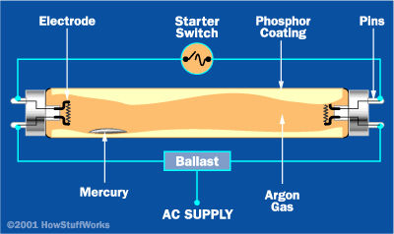

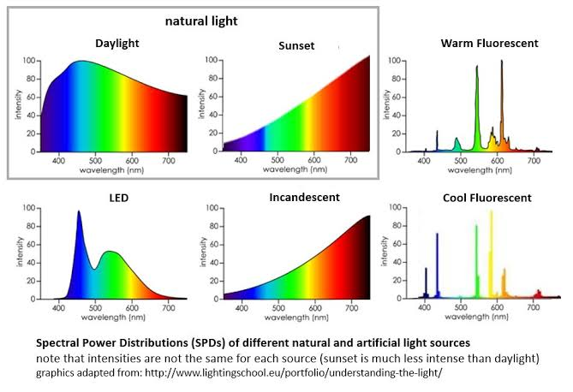

Atomic emission – Phosphorescence
- Similar to normal atomic emission but with a time delay
- Excited electron gets ‘stuck’ in excited state for as much as a couple of hours
- Allows energy to be stored in phosphorescent material which will slowly emit light over minutes – glow in the dark materials

Lasers – Light Amplification by Stimulated Emission of Radiation
- Normal light sources create light of many different colours, all travelling in random directions and with no particular phase relationship between photons
- Lasers in contrast are said to be ‘coherent’, which encompasses a few ideas:
  - all photons have same wavelength/frequency/colour/energy
  - all travelling in same direction so maintains very
narrow beam over enormous distances
  - all in phase
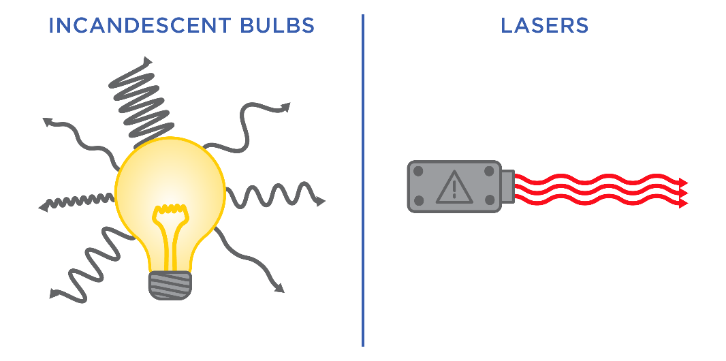

How do lasers work?
- Normally when an excited electron relaxes, the photon is emitted in a random direction – spontaneous emission
- If a photon of the right energy passes by an excited electron it can trigger the relaxation and emission, in this case the emitted photon travels in the exact same directions as the stimulating photon and perfectly in phase with the stimulating photon – stimulated emission
- This takes you from one initial photon to two
which can each stimulate further emission – creates a cascade chain reaction – light amplification
- Just need to start with a collection of excited atoms
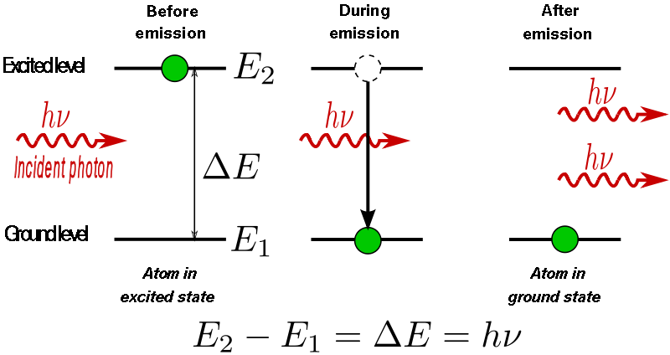

Applied spectra
- Since each element has a unique absorption/emission spectrum, these spectra can be used to identify elements
- Used to determine the chemical composition of stars
- A star should emit a continuous spectrum
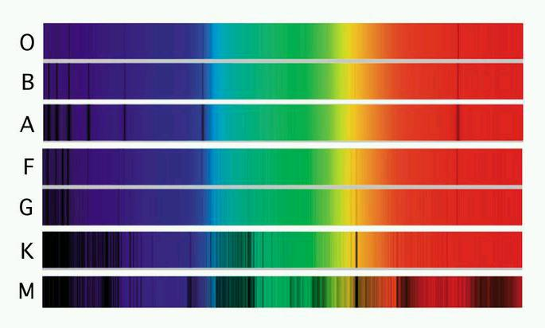
- Different types of star have had different colours absorbed from their spectrum by elements in their outer layers

Example
- Use the diagrams in the powerpoint (slide 86) to determine which spectral classes of star (O, B, A, F, G, K and/or M) contain H in their outer layers?

- Which contain He in their outer layers?

Doppler shift of absorption spectra
- atomic absorption leads to very characteristic absorption patterns
- When looking at distant stars the familiar pattern is recognizable but it appears in the wrong place – shifted towards the red
- The further away the star is the more it is redshifted – expanding universe
- Caused by doppler effect – a wave source moving away from an observer results in waves of increased wavelength (more red) so the entire spectrum is shifted

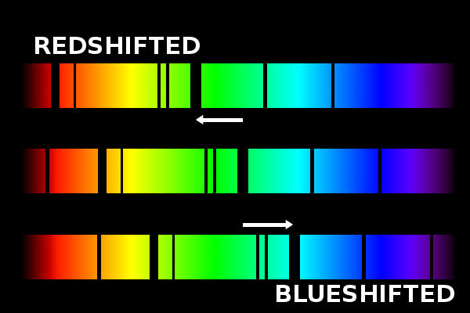

Summary of stellar spectra
- Stars are a long way away – light is by far the best way to gain information about them
- Most information about stars comes from interpretation of the absorption spectra

Information | Evidence
Chemical composition | Characteristic absorption lines
Temperature | Blackbody spectral profile
Relative velocity | Degree of doppler shift of absorption lines
Rotational motion | Smearing of absorption lines due to varying doppler shift

Photovoltaic cells – solar panels
The basics:
- Join between two different semiconductors creates persistent electric field due to local charge separation
- Incident photon excites electron from immobile ground state (valence band) to a higher energy level where electrons can move (conduction band)
- The excited electron leaves behind an ‘electron hole’ or just ‘hole’ – vacancy for an electron – can be thought of as a positive particle
- The electric field pushes the electron to one end of the cell and the hole to the other
- Overall result is a small flow of current – many cells can combine to produce useful amounts of DC
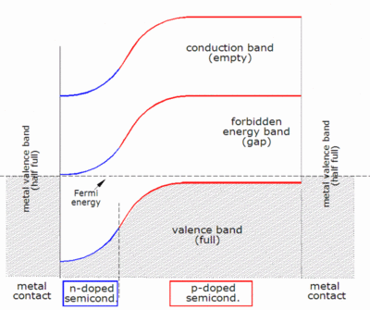

Understanding semiconductors – electron bands
- In a single atom energy levels have single defined energies
- In a solid array of many atoms (metal/covalent network) no two energy levels may have exactly the same energy so the levels of each atom change slightly – resulting in a very large
number of very similar energy levels – effectively becomes a continuous band of allowed energies
- In metals there are partially filled bands, the room allows for easy movement of electrons – conduction
- In non-metals the valence band is full – no room for movement – insulator
- In non-metals if electrons could become excited up from the valence band to the next band up (conduction band) they could conduct but there is a very large energy gap (band gap)
- In semi-conductors this band gap is relatively small, allowing for conduction under the right circumstances

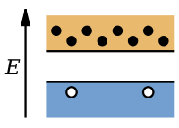
N and P semiconductors
n-type (doped with electron donor)
- increased number of electrons in conduction band,
small number of holes in the valence band
- electrons as primary charge carriers
- e.g. silicon doped with phosphorous

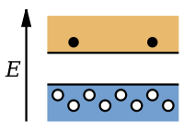

p-type (doped with electron acceptor)
- increased number of holes in the valence band,
small number of electrons in the conduction band
- holes as primary charge carriers
- e.g. silicon doped with boron

P-N Junctions
Junction between n-type and p-type semiconductors
- electrons diffuse from n to p due to concentration gradient – holes diffuse p to n
- holes and mobile electrons combine at junction cancelling out – depletion zone (no charge carriers)
- n-type side becomes positively charges due to lost electrons – p-type side becomes negatively charged due to lost holes
- charge separation at the boundary leading to an electric field pushing electrons back the opposite way – prevents process from spreading further
- dynamic equilibrium

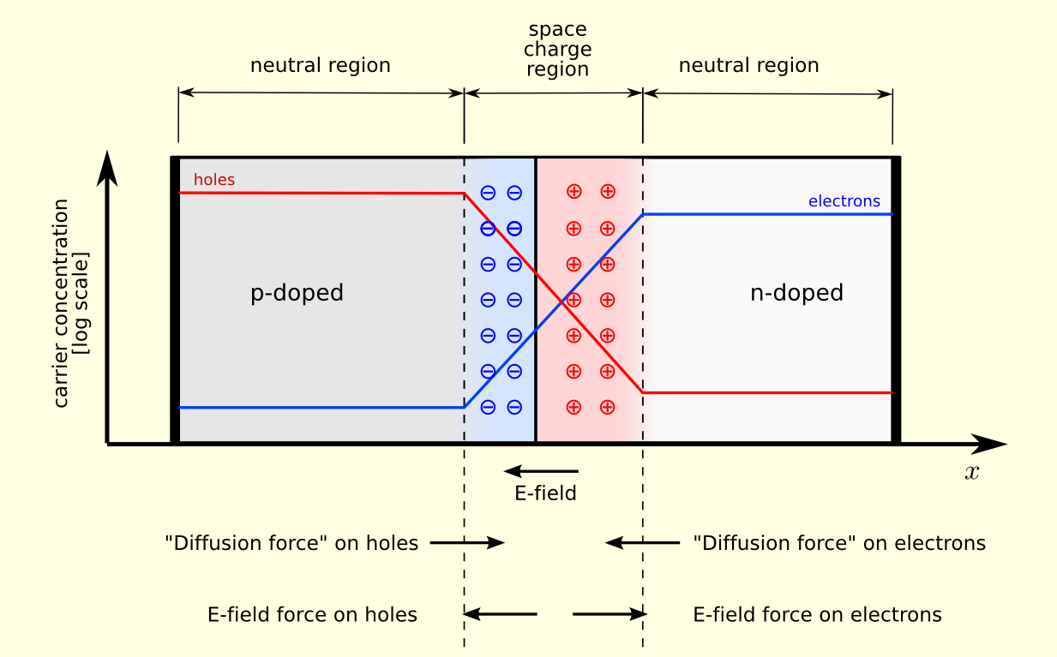

Light emitting diodes
The simple version:
- Junction of two different semiconductors
- n-type holds high energy electrons (similar to excited electrons but actually stable)
- p-type holds electron holes in a lower energy level
- Stable until a voltage is applied
- With enough voltage the electrons from the n-type semiconductor are pushed across to the p-type where they relax into the holes releasing the excess energy as light of a wavelength specific to the energy level gap

Light emitting diodes - detail
- similar to photovoltaic cells – makes use of p-n junctions – almost the same process in reverse
- high energy (conduction band) electrons from the n-type semiconductor are pushed by an external voltage across to the p-type semiconductor where they combine with low energy (valence band) holes
- This is a transition down in energy so the excess energy is released as a photon with a specific energy equivalent to the band gap (difference between energy level bands)
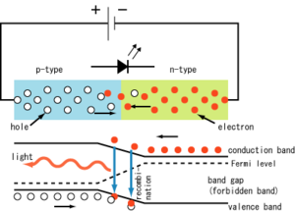

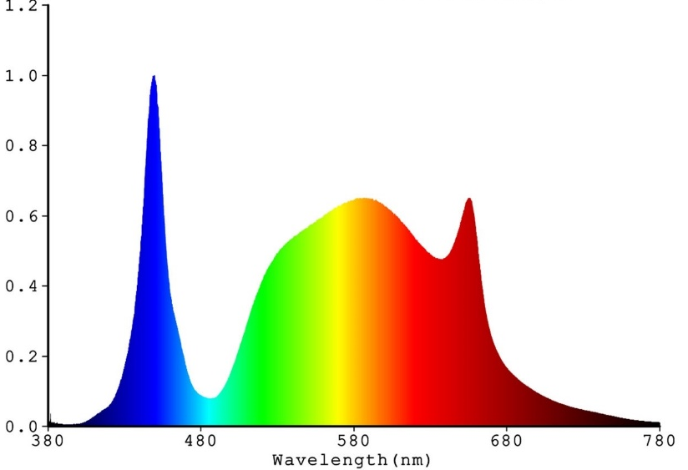
Colour of LEDs
- Initially monochromatic determined by band gap – large band gap = more blue
- Can use phosphors in the housing to convert down to lower energy colours to create a mixture of colours – white light
- Blue LEDs are most versatile in that sense
– highest energy so other visible colours can be created
- However blue LEDs require the largest band gap
which makes them harder to make – tend to break

LEDs pros and cons
Pros | Cons
Much more energy efficient than older light sources | Harder to use with dimmers
Much longer lifespan | Tend to decrease in brightness over their lifespan
Less waste heat | Can fail prematurely in high temperatures
More physically durable
Increasingly affordable
Good at directional light

LEDs and Photovoltaic Cells summary

LEDs | Photovoltaic cells
n-type semiconductor contains trapped, excited electrons | electric field naturally occurring in n-p junction would push electrons from the p-type semiconductor to the n-type semiconductor
p-type semiconductor contains holes that the electrons can relax into | p-type semiconductor does not contain electrons in the conduction band where they could move, so no current flows
electric field naturally occurring in n-p junction prevents electrons and holes recombining | incident light excites valence band electron in p-type to the conduction band where it can move
external voltage can push the excited electrons against the field allowing them to relax and emit light based on the band gap | electron current flows from p-type to n-type pushed by electric field

X-ray generation
X-rays very useful due to high penetration ability:
- Used in medical imaging
- Detecting flaws/wear in metals and joins e.g. welds in airplane fuselage
- X-ray crystallography – used to determine detailed structure of crystals from diffraction pattern (λ≈bond length)
2 main types:
- Characteristic radiation – a few specific wavelengths specific to the element being used
- Brehmsstrahlung – continuous spectrum of x-ray wavelengths up to a maximum energy

X-ray vacuum tube
- Current through tungsten filament heats – causes thermionic emission of electrons into vacuum
- Voltage (≈50 kV) across the two electrodes accelerated the electrons towards the target
- Accelerated electrons bombard tungsten target
- ~99% of energy becomes heat but ~1% can become x-rays through certain interactions with
tungsten anode
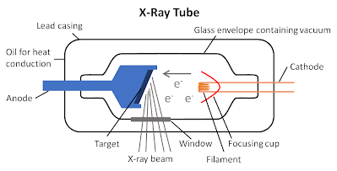

Characteristic radiation
- High energy free electron strikes inner shell electron in an atom giving it enough energy to eject it from the atom
- An electron from a higher energy level relaxes to fill the vacancy – releases excess energy as a photon
- Exact amount of energy determined by element (characteristic), if large enough energy it will be an x-ray
- Essentially atomic emission

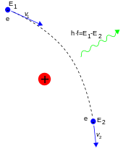
Brehmsstrahlung (braking radiation)
- When a charged particle is decelerated by passing by another charged particle it emits electromagnetic radiation to satisfy conservation of energy
- If the deceleration is large enough, then high energy radiation including x-rays can be emitted

Energy of brehmsstrahlung
- If the decelerated particles loses all its kinetic energy (direct collision with nucleus) this creates the maximum energy photon – there is a maximum energy (minimum wavelength)
- Maximum energy depends on accelerating voltage
if V=50 kV, then E_{max}=50 keV
- More normally a particle will lose its energy through multiple steps leading to wide range of possible energies with less than the maximum being most prevalent – continuous spectrum up from the minimum wavelength
- The closer the electron passes to the nucleus the greater the deceleration

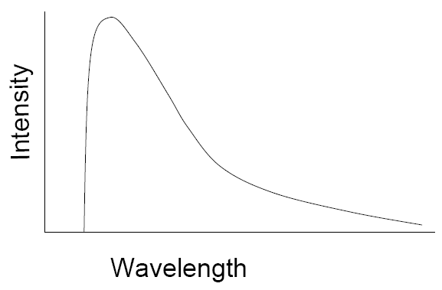

Typical X-ray spectrum
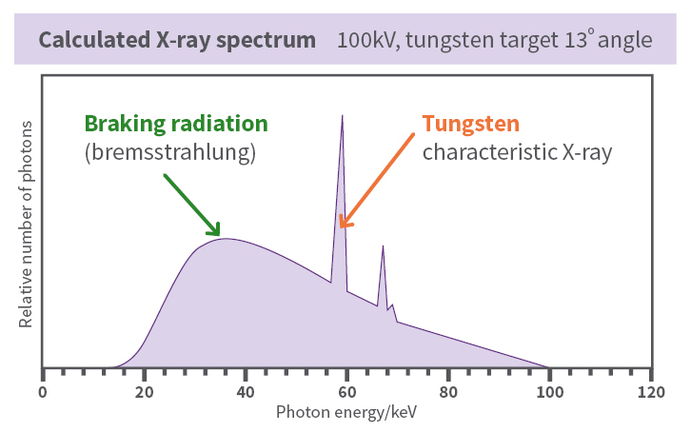

Example
- An x-ray tube is set up with a potential difference of 80 kV. Determine the maximum energy, maximum frequency and minimum wavelength of photon that can be emitted?

Example
an X-ray tube with a molybdenum target has a potential difference of 50.0 kV . Calculate the:
- Max kinetic energy of bombarding electrons in eV and J.
- Max energy of emitted photons in J.
- Max speed of bombarding electrons.
- Max frequency of emitted X-rays
- Minimum wavelength of emitted photons.
- Photon energy of a characteristic emission (0.6 x 10⁻¹⁰m) in J and eV.

Revision
- Explain why the double slit experiment was significant in the development of our understanding of the nature of light.

- Explain why the photoelectric effect was significant in the development of our understanding of the nature of light.

- Explain the pattern of alternating bright and dark fringes produced by the double-slit experiment.

- Protons traveling at 896 m s⁻¹ are fired at a single 0.2 nm wide slit, is it reasonable to expect to observe diffraction in this scenario?

- Compare the spectrum observed from helium in a gas-discharge lamp to that observed from daylight shone through a cloud of helium. Include a sketch of each of the spectra.

- Compare fluorescence and phosphorescence.

- Outline the process of stimulated emission and in doing so describe the unique characteristics of light emitted by a laser.

- Briefly explain how the light from a distant star can be used to determine information about:
  - the star’s chemical composition
  - the star’s temperature
  - the star’s motion relative to the earth
  - the star’s rotational motion

- Determine the maximum wavelength of light that could create current in a photovoltaic cell with a band gap of 1.9 eV.

- Explain how a blue LED can be used to create white light.

- Explain whether a blue LED will need a larger or smaller band gap than a red LED.

- Sketch a graph of maximum kinetic energy of photoelectrons against incident light frequency for a metal. Explain the meaning of the following:
  - gradient
  - x-intercept
  - y-intercept

- A 5 mW blue laser (380 nm) is shone on a sodium plate (W_{Na}= 2.28 eV), in a circuit as shown to the right.
A
  - Determine the maximum current that could flow from the sodium plate to the other electrode.
  - Determine the stopping potential for this arrangement.
  - Draw a graph of current against voltage for this arrangement (assume maximum current is reached at 1.5 V).
  - Draw a graph of current against voltage if the 5 mW laser was replaced with a 10 mW laser.
  - Draw a graph if the sodium plate was replaced with a calcium plate (W_{Ca}=2.90 eV)
  - Draw a graph of current against voltage if the blue laser was replaced by a 190 nm, UV laser that emitted photons at the same rate as the original laser.
  - Draw a graph of current against voltage if the blue laser was replaced with a 670 nm, red laser that emitted photons at the same rate as the original laser.
  - Explain why changing from a 5 mW blue laser to a 5 mW UV laser would actually decrease the maximum current.

- Tungsten is used as the target in an x-ray vacuum tube with an accelerating voltage of 30 kV. The energy level diagram for tungsten is given below:
ionisation
ground state
1st excited state
2nd excited state
n = 1 E₁ = -8.98 keV
n = 3 E₃ = -0.07 keV
n = 2 E₂ = -0.93 keV
n = 4 E₄ = -0.01 keV
n = ∞ E = 0 keV

  - Determine the number of possible transitions for an excited electron in n=4?
  - Calculate the minimum wavelength for characteristic radiation produced from this x-ray tube.
  - Calculate the minimum wavelength for braking radiation produced from this x-ray tube.

Revision Solutions

- The double-slit experiment showed light diffracting and interfering, both of which are wave behaviour. Our best explanation of this experiment relies on light behaving as a wave, not a particle.

- The photoelectric effect shows that the energy of light is present in discrete chunk, and that the quantity of energy carried by one of these chunks is dependent on the frequency of the light. This relies on light behaving as a particle, not a wave. If light were a wave there should not be a sharp threshold frequency, below which, no photoelectrons are emitted.

- Each of the two slits functions as a point source for the light because of diffraction. The light spreads out in arcs from each of the slits and the two sets of light interfere. Where constructive interference occurs (e.g. crest meets crest), a bright fringe is observed. Where destructive interference occurs (e.g. crest meets trough), a dark fringe is observed.

$$λ=\frac{h}{mv}=\frac{6.63×{10}^{-34}}{1.67×{10}^{-27}×896}=0.443 nm$$
$$0.443>0.2 so diffraction is very likely observable$$

- Helium in a gas-discharge lamp will emit just specific colours of light:
BLACK
lines of colour

White light shining through a cloud of helium will be a full rainbow with the same specific colours missing:
RAINBOW
black lines

Fluorescence | Phosphorescence
Both are examples of atomic absorption followed by atomic emission. In each, an electron in the material absorbs a photon of light becoming excited, before re-emitting the absorbed energy as photons as it relaxes.
The absorbed photon is high energy (typically UV so not visible) and the emitted photons are lower energy, visible. Occurs when the relaxation happens in multiple steps. | There is a time delay between the absorption and emission, allow the material to glow after any light source has been removed.

- Relaxation and emission by an excited electron in an atom can be triggered by a photon of the exact same energy as would be emitted passing nearby. The newly emitted photon will be of the exact same frequency as the stimulating photon (because they are the same energy), will be perfectly in phase with the stimulating photon and will be heading in the same direction as the stimulating photon. This is referred to as coherent light, when all the photons are the same frequency/wavelength, are in phase and are heading in the same direction. Lasers work by stimulated emission so emit coherent light.

  - chemical composition: elements in the outer layers of the star will absorb specific colours from the otherwise continuous spectrum, this will create characteristic black absorption bands that can be used to identify specific elements
  - temperature: the peak wavelength of blackbody radiation shortens with increasing temperature, allowing the temperature of the star to be determined by the relative intensities of different colours in the emitted light
  - relative motion: relative velocity between the star and the Earth will shift the wavelength of all incoming light (e.g. receding stars will have all light lengthened in wavelength). There is a simple relationship between the relative velocity and the amount of wavelength shift, allowing the relative velocity to be determined by the amount of wavelength shift of the characteristic absorption bands.
  - rotation: rotation will cause different relative velocities for the two sides of the star causing variation in the amount of wavelength shift. This can cause thickening or blurring of the characteristic absorption bands indicating the rotation of the star.

- $E=hf=h\frac{c}{λ}$
$λ=h\frac{c}{E}=6.63×{10}^{-34}\frac{3×{10}^{8}}{1.9×1.6×{10}^{-19}}=654 nm$

- The blue LED will create a fairly narrow range of blue wavelengths, however, adding a phosphor to the device will allow some of the blue light to be absorbed and the energy re-emitted in smaller portions as other colours of light allowing a somewhat continuous spectrum to be achieved.

- A blue LED will need a larger band gap than a red LED, blue photons carry more energy than red as they are higher frequency, and the minimum energy of the emitted photons is equal to the energy gap between the valence and conduction bands.

E
f

  - gradient = h
  - x-intercept = threshold frequency
  - y-intercept = work function

- A 5 mW blue laser (380 nm) is shone on a sodium plate (W_{Na}= 2.28 eV), in a circuit as shown to the right
  - $E=hf=h\frac{c}{λ}=6.63×{10}^{-34}\frac{3×{10}^{8}}{380×{10}^{-9}}=5.23×{10}^{-19}\frac{J}{photon}$
$$photons/s=\frac{0.005}{5.23×{10}^{-19}}=9.55×{10}^{15} photons/s=9.55×{10}^{15} electrons/s$$
$I=\frac{q}{t}=\frac{9.55×{10}^{15}×1.6×{10}^{-19}}{1}=0.00153 A=1.53 mA$
  - $V_{0}=\frac{E}{q}-\frac{W}{q}=\frac{5.23×{10}^{-19}}{1.6×{10}^{-19}}-2.28=0.991 V$

2
I (mA)
V (V)
-1
1
1.5

2
I (mA)
V (V)
-1
1
1.5
3

2
I (mA)
V (V)
-1
1
1.5

  - $E=hf=h\frac{c}{λ}=6.63×{10}^{-34}\frac{3×{10}^{8}}{190×{10}^{-9}}=1.05×{10}^{-18}\frac{J}{photon}$
$$V_{0}=\frac{E}{q}-\frac{W}{q}=\frac{1.05×{10}^{-18}}{1.6×{10}^{-19}}-2.28=4.26 V$$

-2
2
I (mA)
V (V)
-1
1
1.5
-3
-4
-5

  - no current, energy of individual photons less than work function, so no photoelectrons ejected
  - photons from the UV light each carry a larger amount of energy, since the total energy per second has remained the same the number of photons emitted per second will be less, and so the number of photoelectrons ejected per second and therefore the current will be less.

- Tungsten is used as the target in an x-ray vacuum tube with an accelerating voltage of 30 kV. The energy level diagram for tungsten is given below:
ionisation
ground state
1st excited state
2nd excited state
n = 1 E₁ = -8.98 keV
n = 3 E₃ = -0.07 keV
n = 2 E₂ = -0.93 keV
n = 4 E₄ = -0.01 keV
n = ∞ E = 0 keV

- 6, as shown above

- $λ_{minimum} corresponds to E_{max}=8.98-0.01=8.97 keV=8970 eV$
$$λ=h\frac{c}{E}=6.63×{10}^{-34}\frac{3×{10}^{8}}{8970×1.6×{10}^{-19}}=1.39×{10}^{-10}m=139 pm$$

- $E=qV=1.6×{10}^{-19}×30000=4.8×{10}^{-15}J$
$$λ=h\frac{c}{E}=6.63×{10}^{-34}\frac{3×{10}^{8}}{4.8×{10}^{-15}}=4.14×{10}^{-11} m=41.4 pm$$

